**Report about conducted load test**

**Date:** 15/08/2022

**Author:** Vladyslav Kliucharov

**Application:** BlogEngine.NET version 3.2

**Environment:** Test Environment VirtualBox (Version 6.1.34 r150636 (Qt5.6.2))

**Test Environment configuration (RAM, CPU etc.):**

|  |  |
| --- | --- |
| **Processor** | 11th Gen Intel(R) Core (TM) i7-1185G7 @ 3.00GHz 3.00 GHz (4 core) |
| **RAM** | 4 GB |
| **Hard Disk** | 60 GB |
| **Operating System** | Windows 10 Enterprise (21H2) |

1. **Why such testing was conducted:**

The report is included two methods of testing:

1. Smoke testing - was conducted to verification that the crucial functions of a program can be run and executed in the main workflow

2. Stability Testing - was conducted to define the ability of a software application to continuously function over a long period of time

1. **Test script description:**

The features to be tested have been logically grouped to be covered by 3 threads of users "Admin script", "Editor script" and "Anonymous script". These scenarios were combined in one script followed by load requirement analysis for the modules. The below table captures the features covered by each script. The implement probabilities usage was divided by percentages for all threads (shown below tables):

|  |  |
| --- | --- |
| **Admin script** | **Editor script** |
|  |  |

|  |  |  |
| --- | --- | --- |
|  | **Anonymous script** |  |
|  |  |  |

Scenario to implement probabilities usage:

|  |  |
| --- | --- |
| 1. Home Page: 15%  2. Open Random Date: 10%  3. Open Predefined Date: 30%  4. Search by Name: 30%  5. Open Large Calendar: 10%  6. Open Contacts: 5% | 1. Open Random page (yes/no): 50% / 50%  2. Open post (yes/no): 80% / 20%  3. Random or First (yes/no): 65% / 35%  4. Comment (yes/no): 20% / 80% |

1. **Tests:**  
   **Test run preconditions:**

* CSV file with Random dates
* Warmup script was running before each test run
* Before each new test script run, the webserver was reloaded, the test executed in NON-GUI mode
* From 3 runs in ”Task7” were defined the comfort zone was defined as 45 users
* For the low load testing the KPI for the test was taken from ”Task7” and user quantity were defined as 22

Scenarios model value was getting from Task7 for durable load model by got results of previous test runs

|  |  |  |  |  |  |
| --- | --- | --- | --- | --- | --- |
| **Thread Group** | **Maximum number of simultaneous users** | **Ramp-Up period** | **Test duration** | **Probabilities usage** | **Number of posts** |
| Thread Group (Admin users) | 2 | 20 | 36000 (sec.) | Pre-Defined | 1000 |
| Thread Group (Editor users) | 10 | 100 |  | | |
| Thread Group (Anonymous users) | 10 | 100 |

1. **Short summary on conducted tests:**

The server and application worked stable according to the received test results. For the tests generated 1000 posts. For receiving the correct test results script “Task10” was running 2 times. The system works stable by the low load in a 10 hour duration (The opportunity to run tests for more than 10 hours wasn't able). For every new run were generated 1000 new posts. Scenarios were running 2 times for clarifying the results. The test result shows a lower "Error rate" max 0.04%. From 8GB of RAM was used a max of 3.39GB. The total count throughout was maxed at 7.45 req/s. The max usage of CPU was on level 78%.

1. **Detailed test results:**

‘Task10’ scripts were running 2 times with post quantities 1000, results fetch in the below table:

|  |  |  |
| --- | --- | --- |
|  | **Run 1** | **Run 2** |
| **Number of posts** | 1000 | 1000 |
| **Throughput (Max)** | 7.67 Req/s | 7.07 Req/s |
| **Error rate** | 0.02% | 0.04% |
| **Response time (Average)** | 2.39 ms | 2.38 ms |
| **Response time (Median)** | 1.99 ms | 1.99 ms |
| **90th Percentile (Mean)** | 1.56 s | 1.69 s |
| **95th Percentile (Mean)** | 3.03 s | 3.45 s |

**Test Run #1**

|  |  |  |
| --- | --- | --- |
| Response Code | Transaction | Error count |
| 500 | Transaction Controller (Add User)  Transaction Controller (Open Profile Page)  Transaction Controller (Save Post) | 11  1  31 |
| 404 | Transaction Controller (Open PredefineDate)  Transaction Controller (Open RandomDate)  Transaction Controller (Search By Name) | 4  2  1 |
| 401 | Transaction Controller (Edit Post) | 1 |

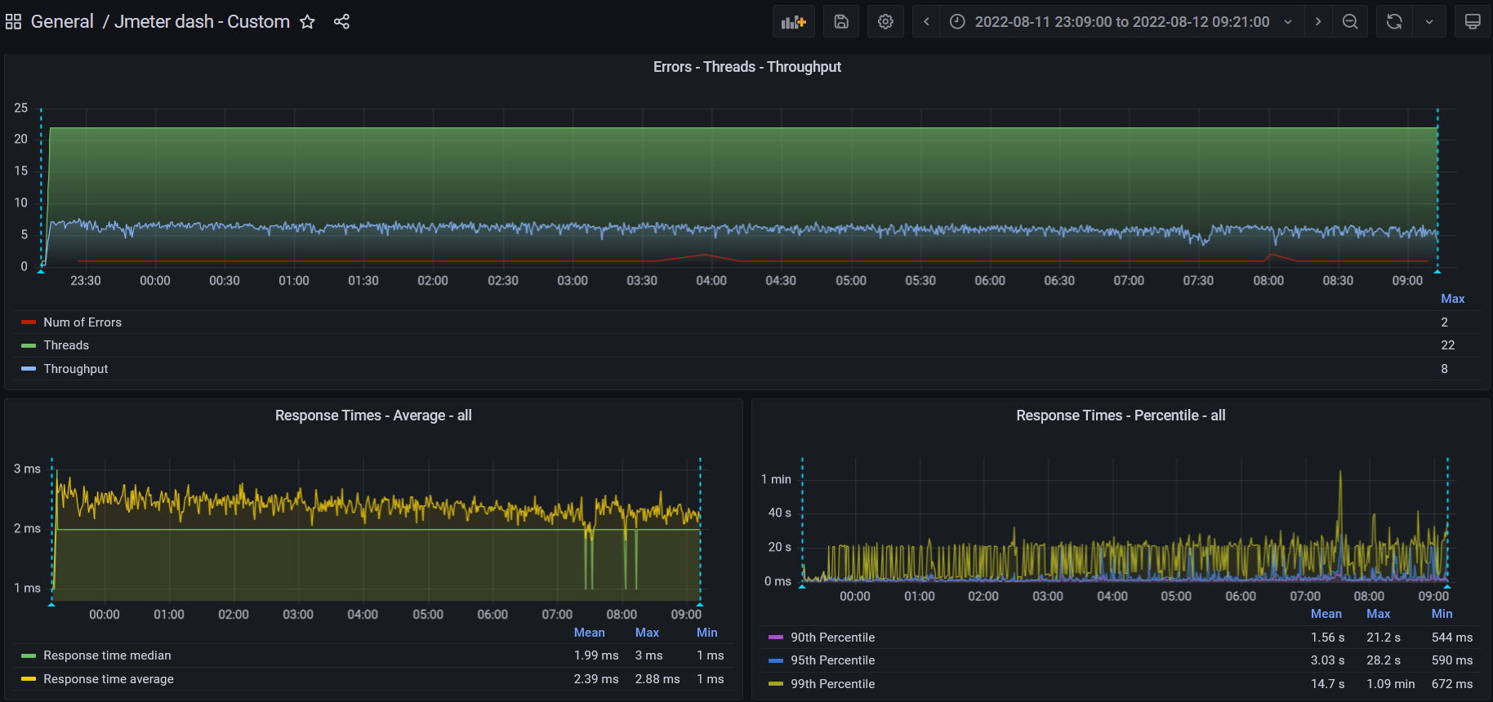

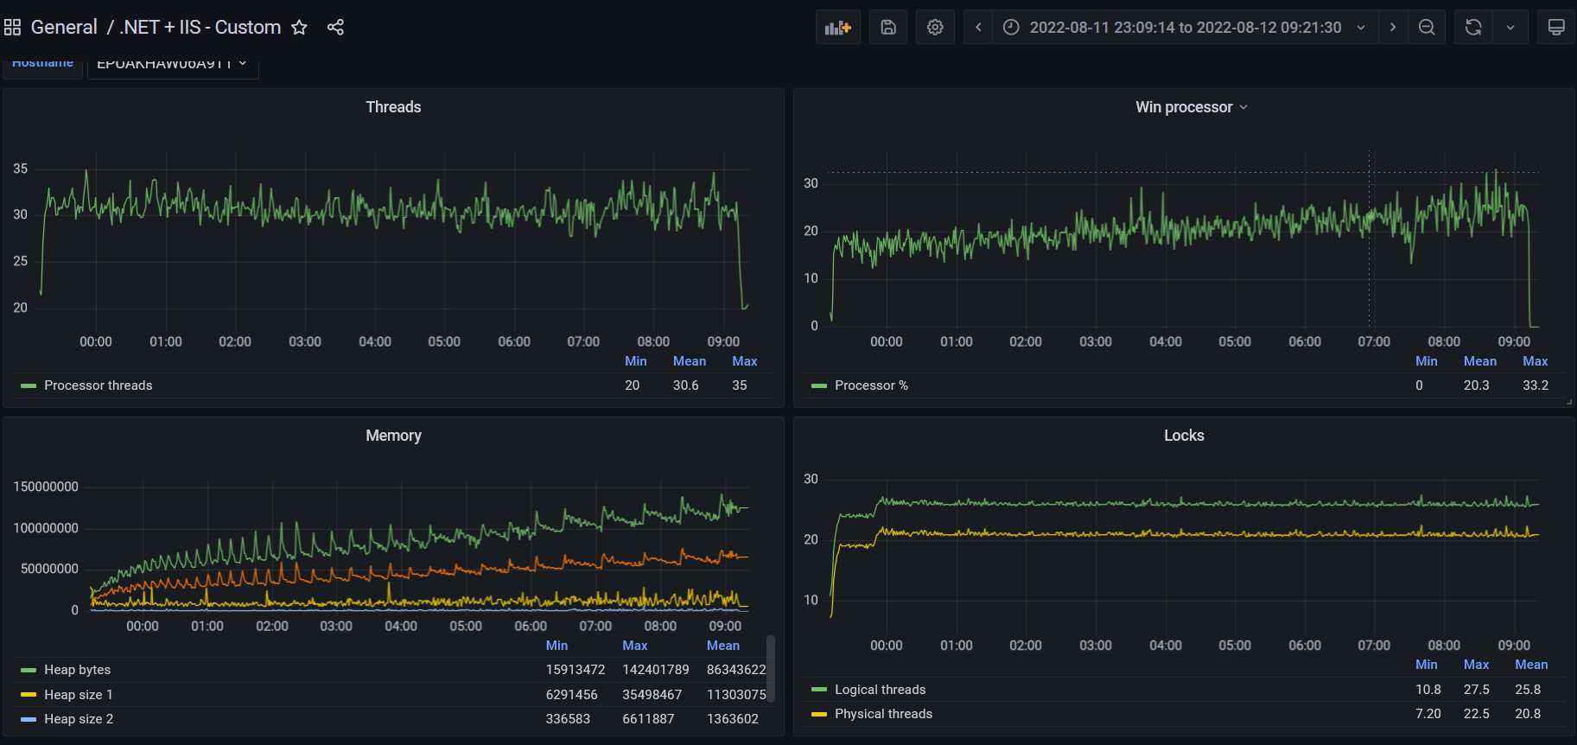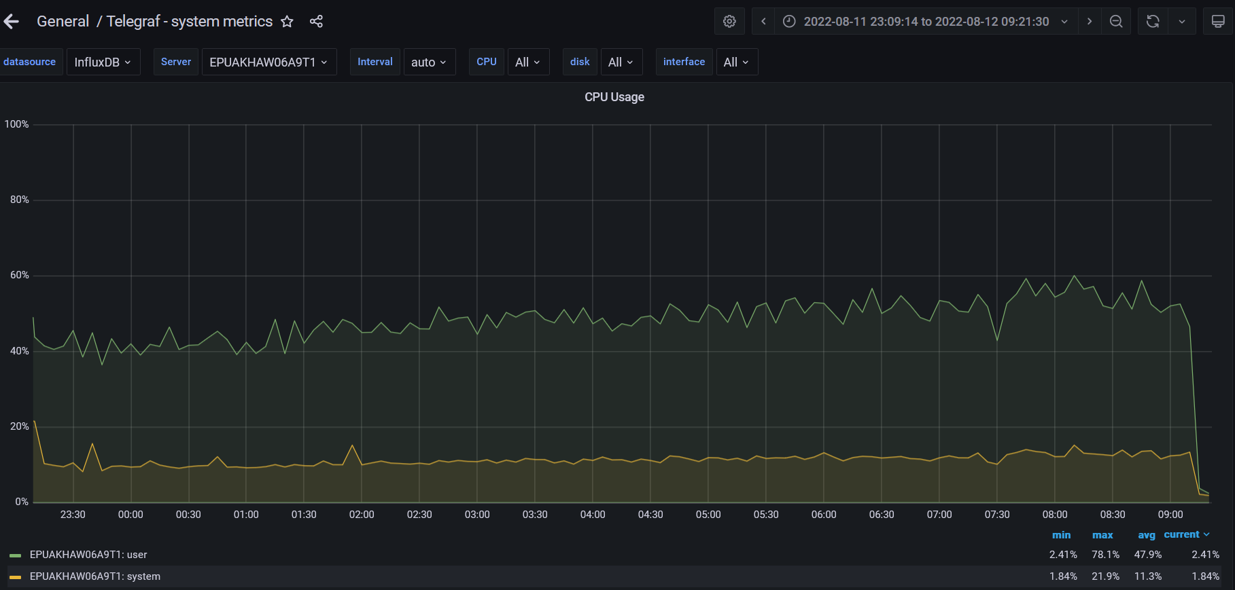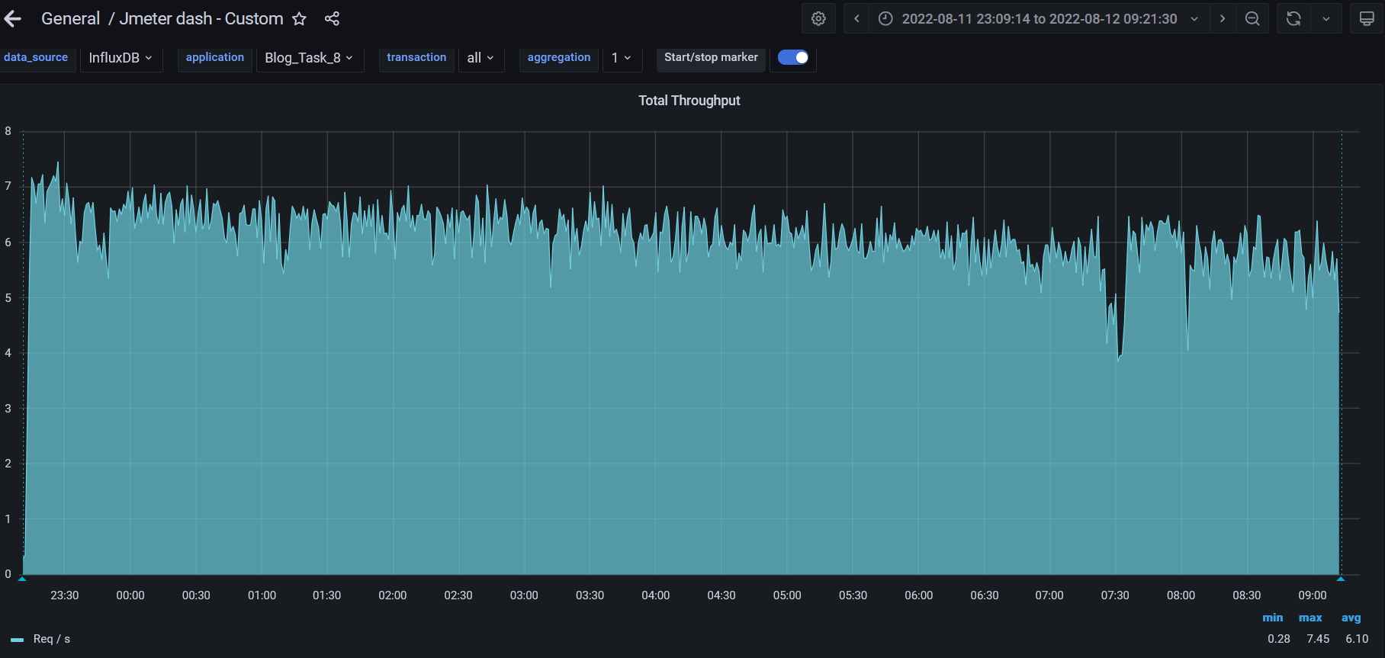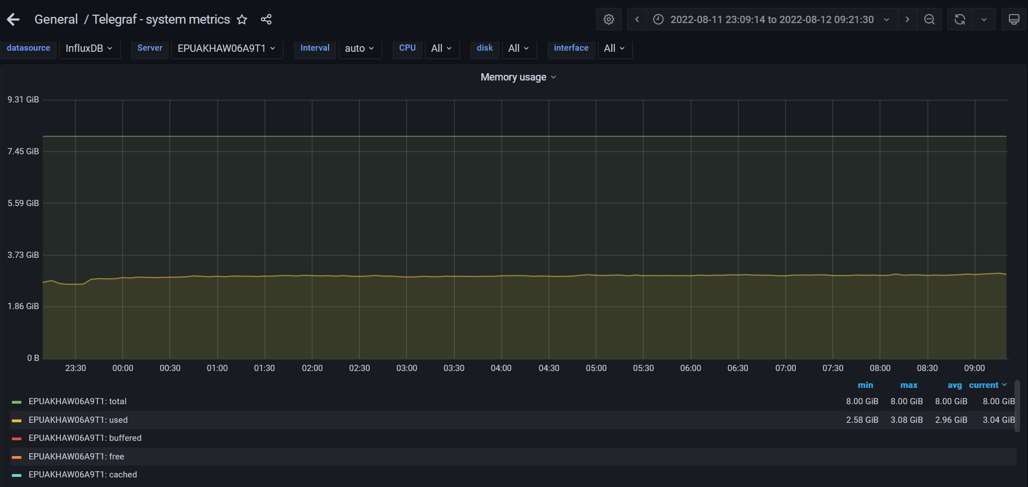

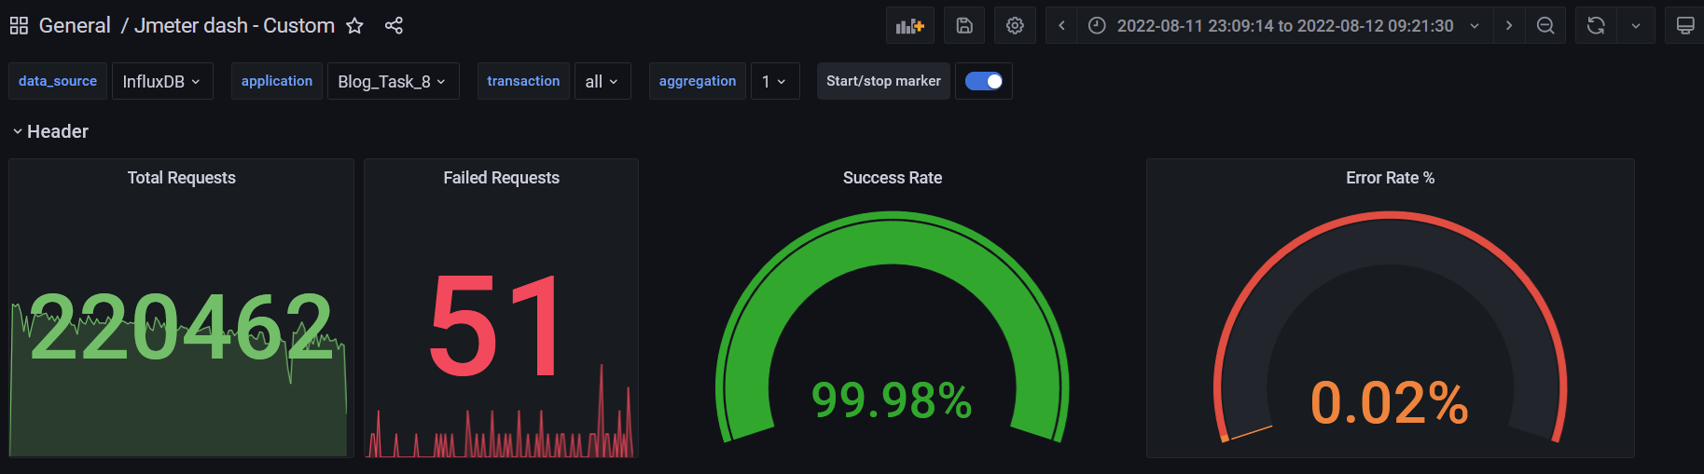

**Test Run #2**

|  |  |  |
| --- | --- | --- |
| Response Code | Transaction | Error count |
| 500 | Transaction Controller (Add User)  Transaction Controller (Delete User)  Transaction Controller (Open Date)  Transaction Controller (Open Post)  Transaction Controller (Open Profile Page)  Transaction Controller (Save Post) | 12  3  1  1  1  56 |
| 404 | Transaction Controller (Open Home Page Anonymous)  Transaction Controller (Open Post)  Transaction Controller (Open PredefineDate)  Transaction Controller (Open RandomDate)  Transaction Controller (Search By Name) | 9  1  4  1  2 |
| Non HTTP response code: java.net.URISyntaxException | Transaction Controller (Edit Post) | 2 |

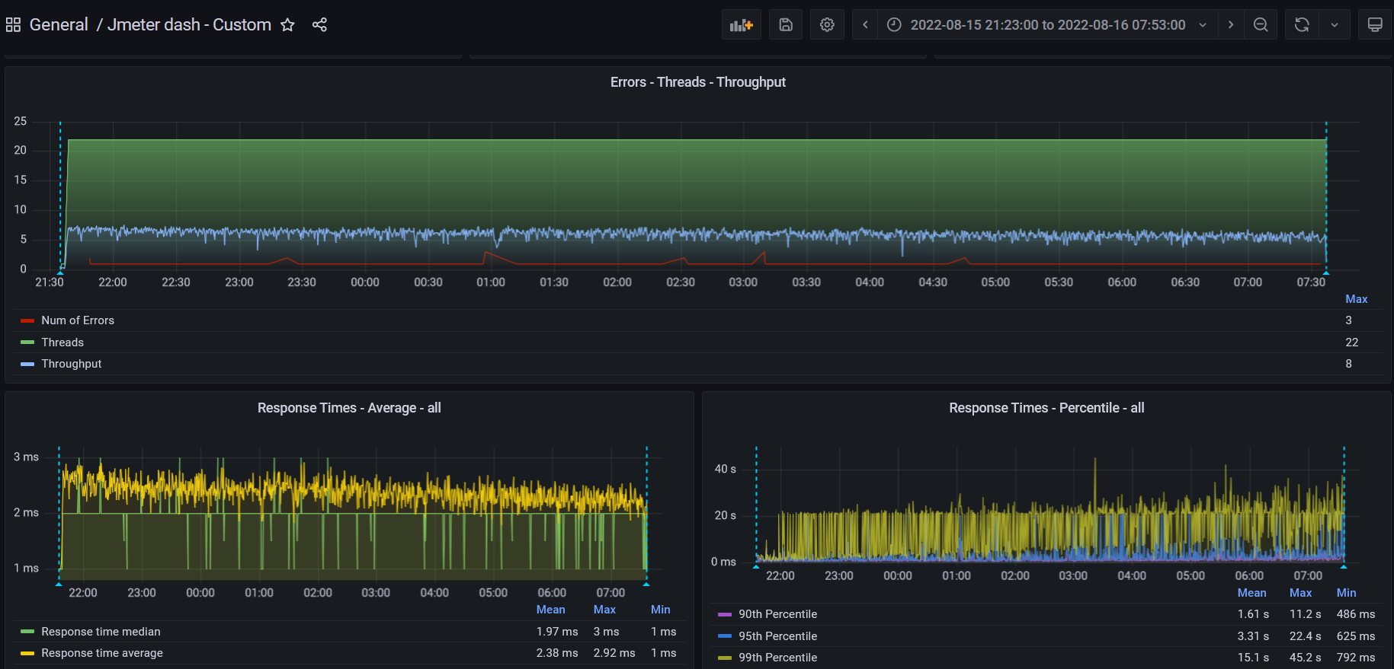

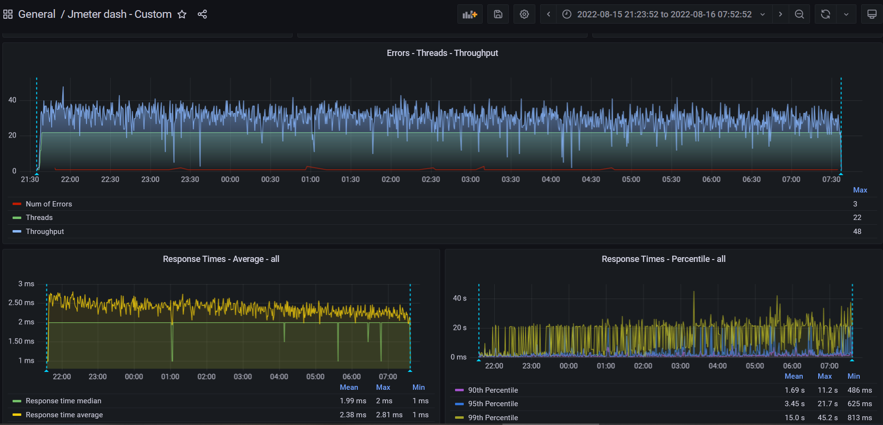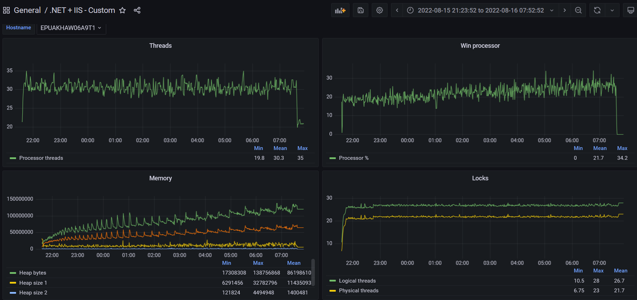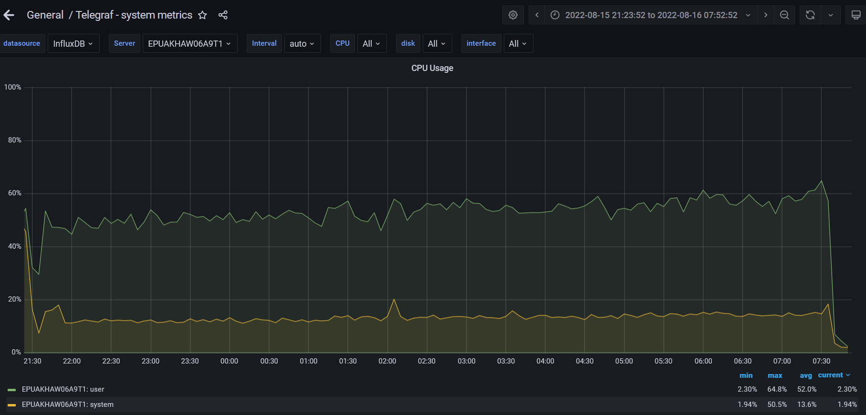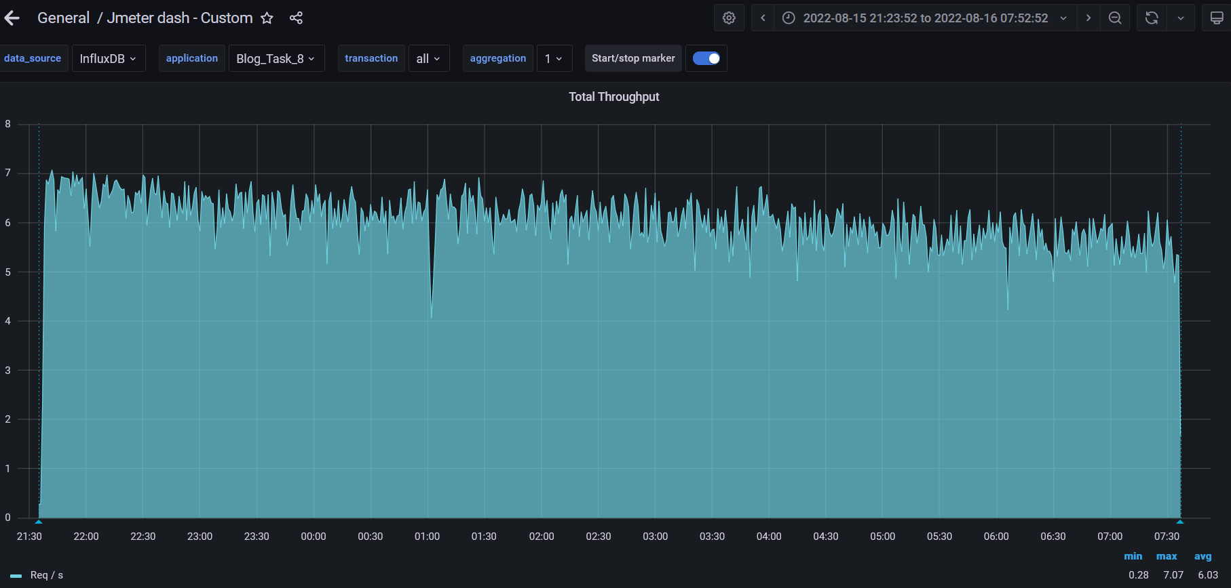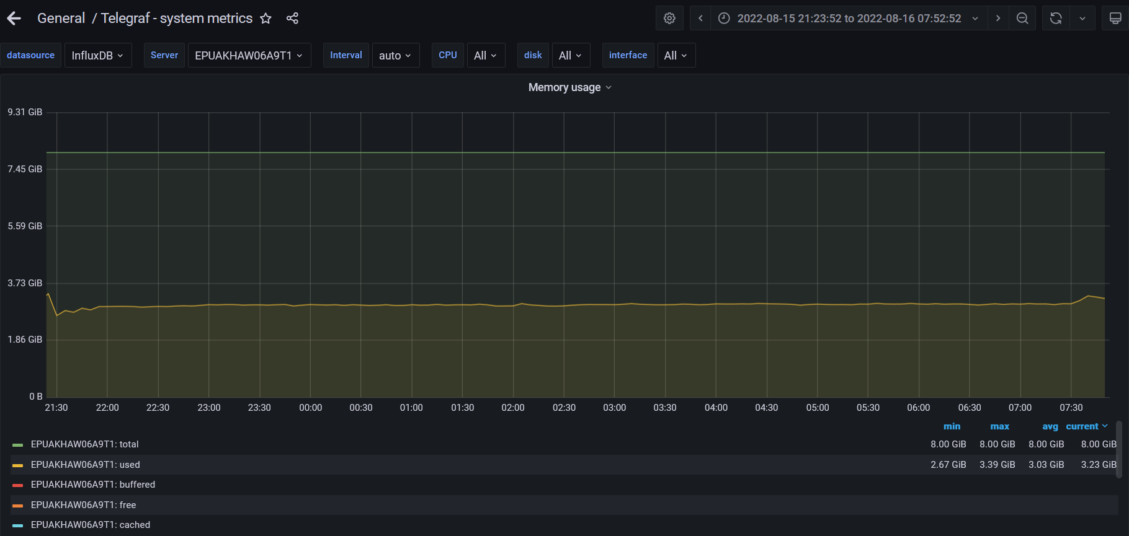

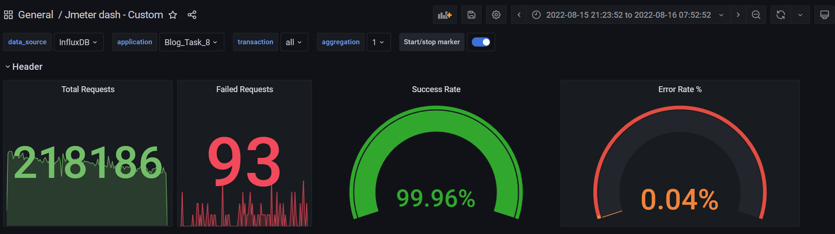

1. **Conclusion:**

The application worked stable under low load according to the received test results. The test result shows a lower "Error rate" max 0.04%. From 8GB of RAM was used a max of 3.39GB. The total count throughout was maxed at 7.45 req/s. The max usage of CPU was on level 78%. The "Response time median" was the same for both runs 1.99 ms and the "Response time average " was the same too 2.39 ms.